Course Title: Special Topics in Power System
Class Project
Due Date: Tuesday June 15, 4:30 PM

Question :
A 3ph, 400 KV network shown in Figure below is supplied through a 3 ph, 50 Hz source; as follows (in V_{b}=345 KV):

V_{A}=0.95 cos(ωt+Π/2)
V_{B}=0.95 cos(ωt-Π/2)
V_{C}=0.95 cos(ωt+4Π/3)

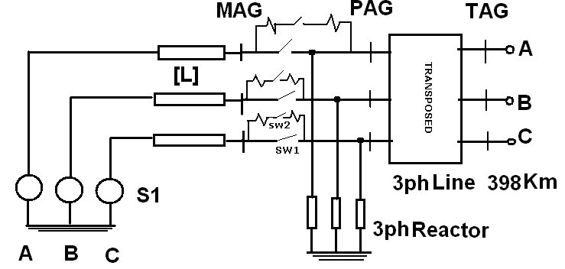
The source impedance is a 3x3 matrix whose diagonal elements: X_{s}=70.65Ω, nondiagonal: X_{m}=-21.95 Ω.
The 3 phase circuit breaker is equipped with closing resistors of 450Ω (this is case a, case b - 200Ω, and case c-800 Ω). And when the auxiliary contacts close before the main one this resistor will be in series with the circuit , and after closing of main contacts open. The closing time of two sets of contacts are given in the next table.
Table -1 closing time of circuit breaker Contacts
Phase | Closing time: aux. con. | Closing time:main con
A | 9.45 ms | 16.85 ms
B | 8.15 ms | 13.45 ms
C | 7.10 ms | 15.10 ms

The 450Ω resistor is divided into two parts of 225Ω. A 440 kV , 95 MVAR, 3 phase reactor is connected to the terminal of Transmission line and its self and mutual reactances are:
X_{s}=1600 Ω
X_{m}=-450 Ω

And the parameters of this transmission line which is open circuit at the end are as follows (in 50 Hz):
R₁ | R₀
0.035 Ω/Km | 0.31 Ω/Km

X₁ | X₀
0.36 Ω/Km | 1.2 Ω/Km

C₁ | C₀
11.5 nF /Km | 8.0 nF/Km

The line is 398 Km and completely transposed. (use the appropriate transmission line model in ATPDraw )
Simulate the problem with ATPDraw software. And for cases a, b and c as defined in above [suggestion ∆t<100 μs, t_{max}= 25 ms]:

- Calculate the transient voltages of the sending and receiving end of the line after closing the circuit breakers. How much energy will be dissipated in closing resistors
- With application of a statistic switch in place of the existing switch find the expected distribution of highest transient voltages at the sending end and receiving end.
- If the circuit breaker opens due to a mal-operation of distance relay after about 10 ms of energization with exact opening times of Table 2, find the recovery voltages across the main contacts, and auxiliary contacts of each phase of circuit breaker.

Table 2 Opening time of contacts of circuit breaker
Phase | Opening time: aux. con. | Opening time: main con.
A | 32.15 ms | 26.95 ms
B | 34.05 ms | 25.45 ms
C | 35.20 ms | 27.10 ms

